40.18: Since 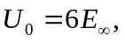 we can use the results from Section 40.3.
